国际引智课程推荐 | 国际和欧洲健康法

2026年华东政法大学秋季国际引智项目课程：国际与欧洲健康法(International and European Law)（课程代码：F202608）

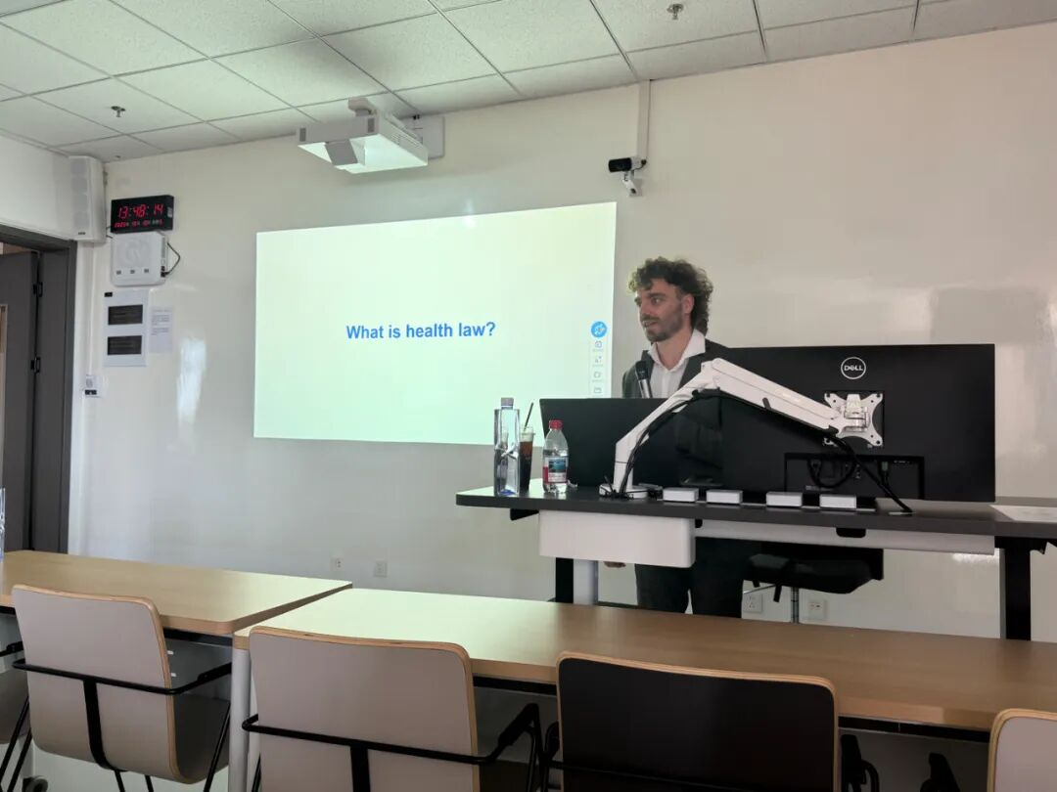

课程主讲人简介
Timo Istace，专业领域涵盖人权法、医疗法、法律哲学和生命伦理学。蒂莫专注于探讨新兴技术在这些领域中的影响，尤其关注神经技术方面的议题。Timo Istace是安特卫普大学的高级研究员，致力于研究神经技术与法律之间的相互作用，特别侧重于人权法和医疗法。此外，他还是安特卫普健康法与伦理学讲席（AHLEC）的活跃成员。他拥有安特卫普大学法学博士学位，以及法学硕士和哲学硕士学位。
Profile
Timo Istace is also a senior researcher at the University of Antwerp, conducting research into the interplay between neurotechnology and the law, with a specific emphasis on human rights law and medical law. his areas of expertise encompass human rights law, medical law, philosophy of law, and bioethics. Timo specializes in exploring the implications of emerging technologies, with a particular focus on neurotechnology, within these domains.Additionally,Timo Istace is an active member of the Antwerp Health Law and Ethics Chair (AHLEC).He holds a PhD in Law, as well as master’s degree in Law and a master’s degree in Philosophy from the University of Antwerp.

院系 School | 中国法治战略研究院
选课对象 Registration Recommendations | 硕士研究生post-graduates  向本科生、博士生开放旁听open to Undergraduates and PhDs
课时与学分 Lecture Hours & Credits | 36学时；2学分 36 Lecture Hours; 2 Credits
授课语言 Language taught | 英语 English
授课时间Date & Time | 2026年9月8日至9月18日，共两周；  8次讲座（4个课时）
授课地点 Location | 松江校区明法东楼D403
选课信息 Basic information

课程内容
本课程由八个讲座（各4课时）构成，包括：
讲座Lectures | 上课时间  Date & Time | 上课地点  Location
1 | 9月8日周二  13:30-16:45 | 松江校区  明法东楼D403
2 | 9月9日周三  13:30-16:45 | 松江校区  明法东楼D403
3 | 9月10日周三  13:30-16:45 | 松江校区  明法东楼D403
4 | 9月11日周四  13:30-16:45 | 松江校区  明法东楼D403
5 | 9月14日周一  13:30-16:45 | 松江校区  明法东楼D403
6 | 9月15日周二  13:30-16:45 | 松江校区  明法东楼D403
7 | 9月16日周三  13:30-16:45 | 松江校区  明法东楼D403
8 | 9月18日周五  13:30-16:45 | 松江校区  明法东楼D403

课程考试：小论文

Content
The first part of the course, Professor Istace began by delving into the historical process of European integration and the rule of law. He systematically explained the diverse legal sources in European health law, including EU law, national laws of member states, and case law of the European Court of Human Rights, as well as the interaction and connection among them. The second part detailed the regulatory structure and judicial application of patients' informed consent rights within the European legal framework. The third part focused on the definition of health-related laws and the concept of health rights, analyzing their manifestations in the European Convention on Human Rights and the EU Fundamental Rights Charter. The fourth part further introduced the latest developments of the health care data system in Europe, including legal coordination between personal information protection and data reuse. Finally, at the end of the course, Professor Istace conducted an in-depth analysis of the criteria for determining patients' capacity for autonomous decision-making.
Final examination: Essay

选课与课程联系方式
请登录研究生系统进行选课。本课程欢迎感兴趣的本科生和博士生参与旁听！
听课请扫描下方课程群二维码，以便获取课程阅读材料及最新通知。


